**Points**

At the lowest level, each glyph in a TrueType font is described by a **sequence of points on a grid**. While two on-curve points are sufficient to describe a straight line, the addition of a third off-curve point between two on-curve points make it possible to describe a **parabolic curve**. In such cases, each of the on-curve points represents an end point of the curve and the off-curve point is a control point. *Changing the location of any of the three points changes the* ***shape of the curve*** *defined*.

The definition of such a curve can be made formal as follows: given three points p0, p1, p2, they define a curve from point p0 to point p2 with p1 an off-curve point. The control point p1 is at the point of intersection of the tangents to the curve at points p0 and p2. *Thus p0, p1 is tangent to the curve at point p0. Similarly p2, p1 is tangent to the curve at point p2.* The curve specified by these three points is defined by a **parametric equation**. For t ranging from 0 to 1, the position of p(t) is a shown:

p(t) = (1-t)2 p0 + 2t(1-t)p1 + t2p2

Curves of the type just described are Bezier quadratic curves. A quadratic curve is shown in FIRGUE 1.

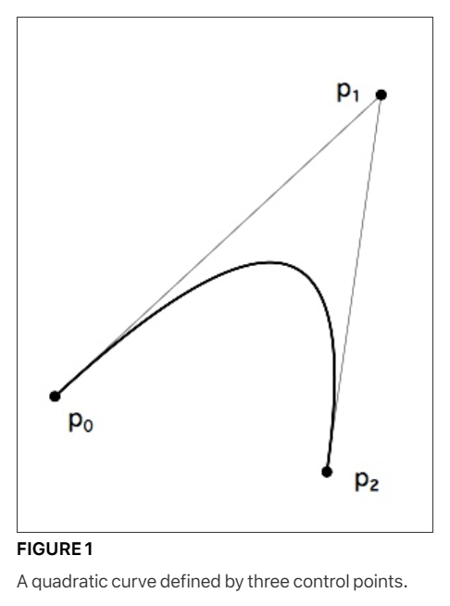

Curves that are parabolic in nature can be represented by a single quadratic curve. More complex curves can be represented by several connected curves. **The tangent-continuous joining** of such components produces a **quadratic spline**. Such a joining occurs when curves are connected in a manner such that their shared points have the same tangent.

Connected quadratic curves have first degree continuity and tangent continuity if each curve point is on the line connecting the two flanking control points.

Such a curve is shown in FIGURE 2. Here two curves, p0, p1, p2 and p2, p3, p4 are connected at their common point p2. Note that in the illustration, points p1, p2, and p3 are colinear.

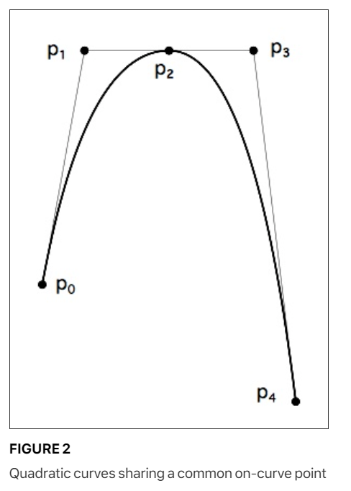

It would also be possible to specify the curve shown in FIGURE 2 with one fewer point by removing point p2. Point p2 is not strictly needed to define the curve because its existence implied and its location can be reconstructed from the data given by the other points. After renumbering the remaining points, we have the curve shown in FIGURE 3.

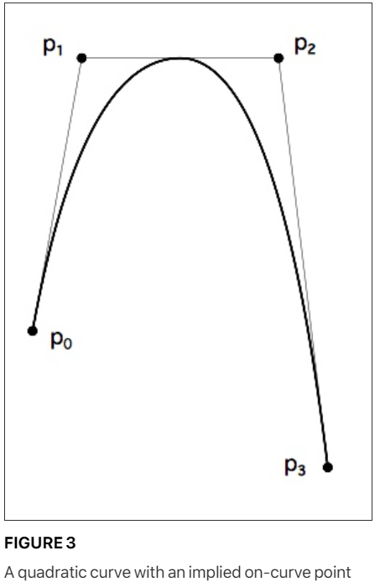

By combining curves and straight lines, it is possible to build up complex glyphs. Such a letterform is shown in FIGURE 4 below. The on-curve points that define the glyph are shown as small black circles. The off-curve points are shown as small open circles.

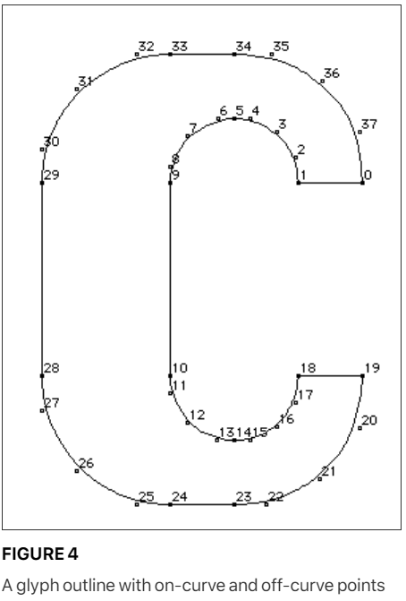

**How many points are necessary?**

In describing a curve, you should use neither too few nor too many points. Often an arc can be described by as few as 3 to 4 points. Curves with a small radius of curvature and curves with inflections will require many more points to faithfully render with quadratic curve. In considering the number of points needed to faithfully render an outline adding points will not necessarily produce a better result. The fewer points that are used to describe a curve, the less space that is needed to store each glyph description and hence the more compact the font. Fewer points also lead to faster scaling. Too few points, however, can result in loss of fidelity to original design. It is therefore desirable to use enough points to faithfully translate the shape of a glyph but not so many that there is a needless loss of space or speed in scaling. In addition to the loss of space and speed, an excessive number of points can result in warbling (rapid modulations in the shape) due to noise in the data or roundoff error. Finally, too many points can also make a font harder to instruct.

FIGURE 13, “Three circles too few(left), too many(middle), just right(right).” Shows three different attempts to define a circle. In the leftmost example, four off-curve points are used but are insufficient to produce a round shape. The rightmost example uses 8 off-curve points which results in a circular curve that can be made a perfect circle with the exception of an arbitrarily small error factor. The middle example, also produces an accurate circular shape but uses more points than are necessary. In particular the on-curve points, located at the midpoints of the tangents to the curve, add no extra information and might have been omitted.

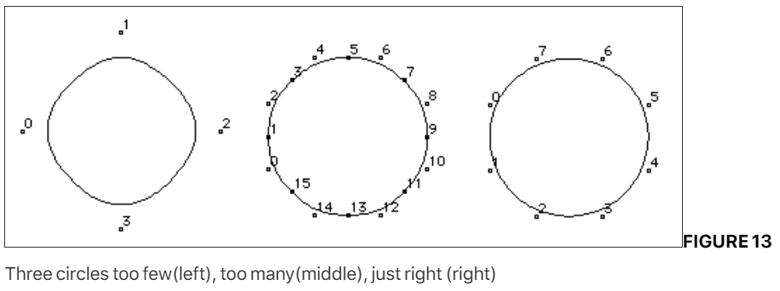

**Where should points be located?**

A glyph outline should have points on extrema. That is, the curve positions with minimum x-value, minimum y-value, maximum x-value and maximum y-value should be marked by curve points. Some systems for representing outline fonts require an on-curve point at the point of tangency. This is not required in TrueType if the tangency point is midway between the flanking off-curve points.

It is, however, important to put an on-curve point at an inflection point in a curve. Inflection points are the point on the curve where the curvature is zero. An inflection point can be implied if it happens to be at the midpoint of the line connecting the off-curve points.

